Access different components of AWS using AWSCLI

Create a 3G EBS volume and attach it to one running instance and create a 1GB partition on that and mount it on one directory no need to make /etc/fstab entry. Remember all this thing using AWS CLI and terminal only.

AWS allows you to create new EBS volumes and you can attach it to instances for extra storage. However, to make it usable as storage inside the instance, you need to mount it to a specific folder.

**Steps:**

1. Create an EC2 instance.
2. Copy the public ip

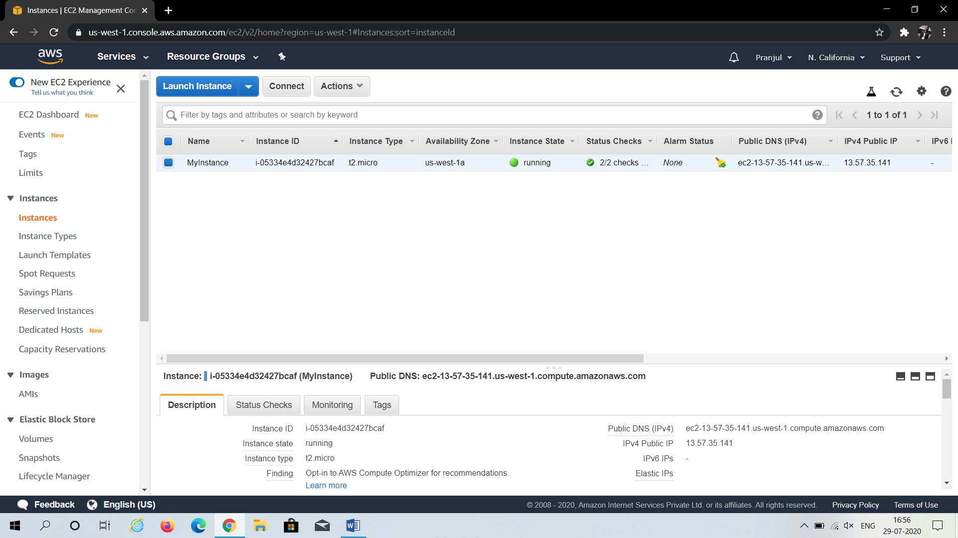

1. Open putty, enter the ip address.
2. From category click on SSH > Auth > Browse the private key file for authentication
3. Click on open

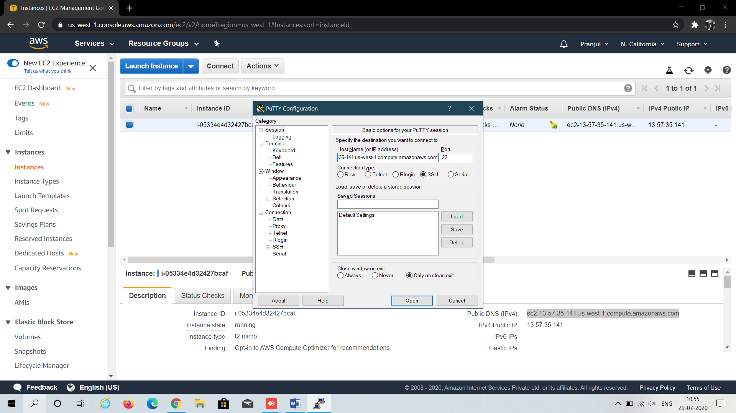

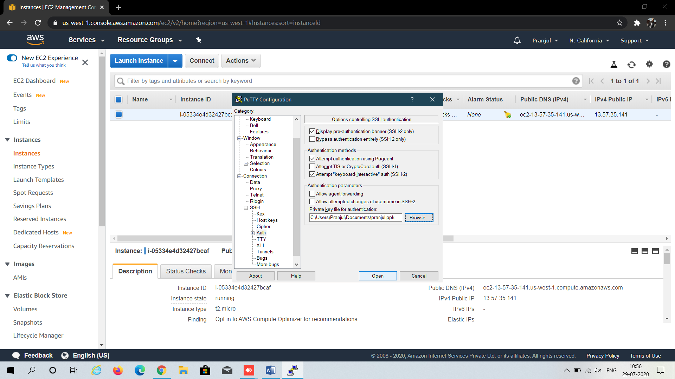

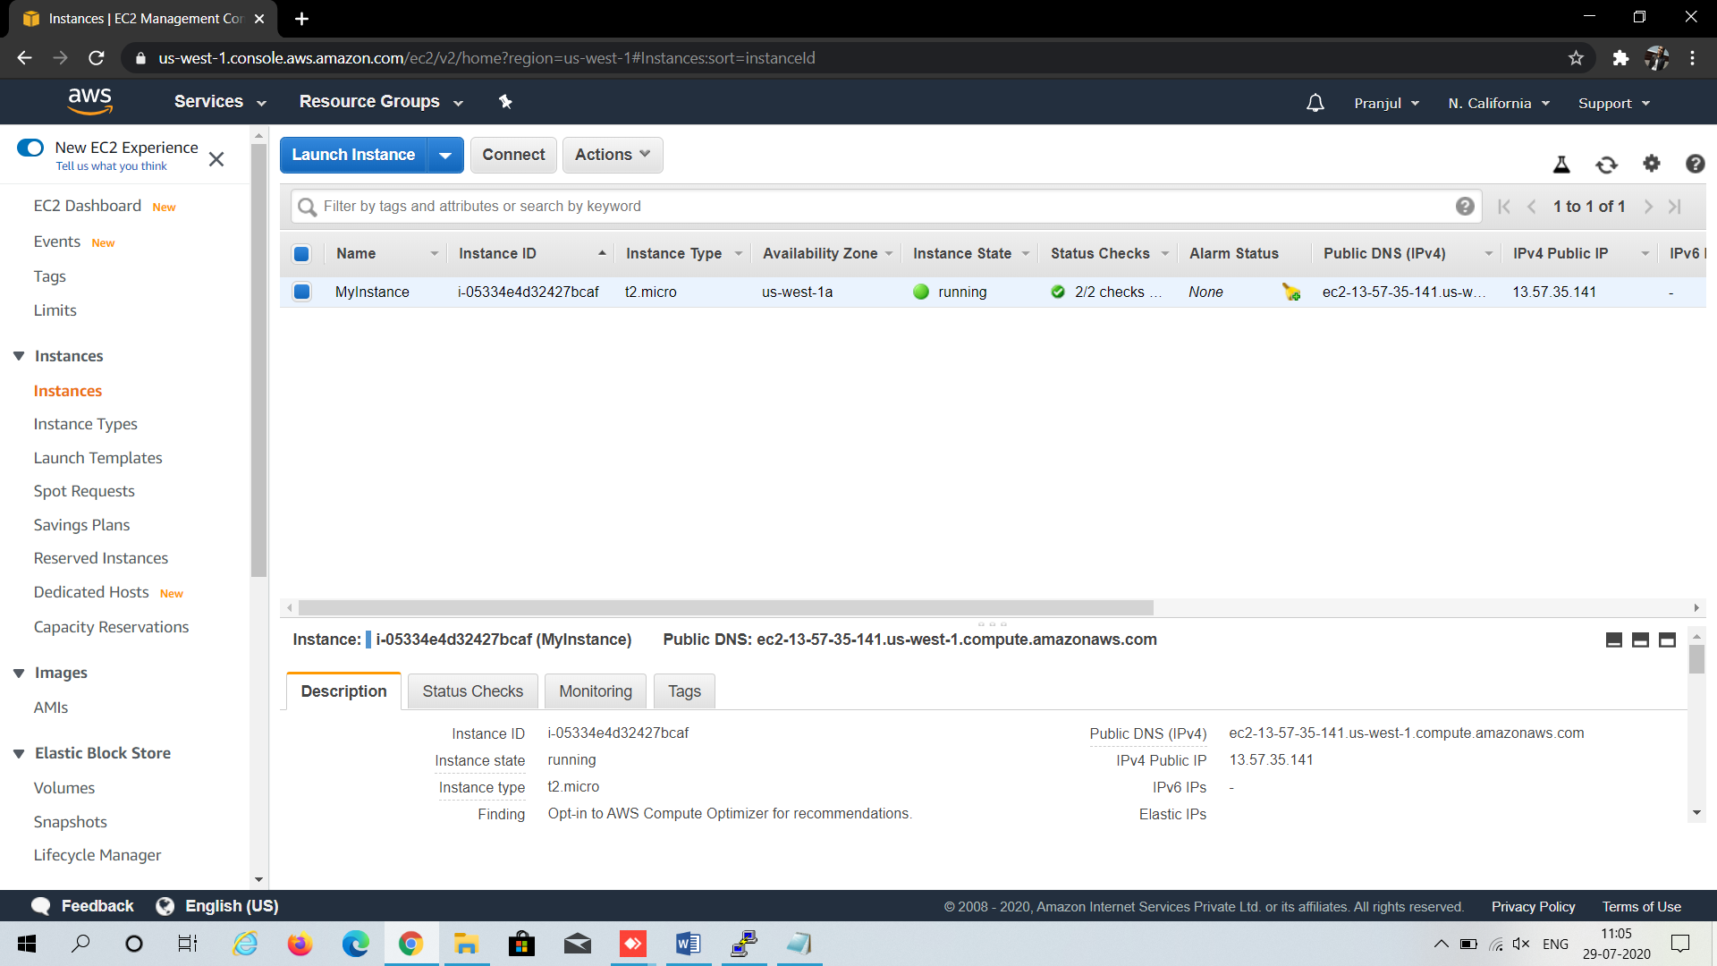

1. Now, for login as: use the following command

**ec2-user**

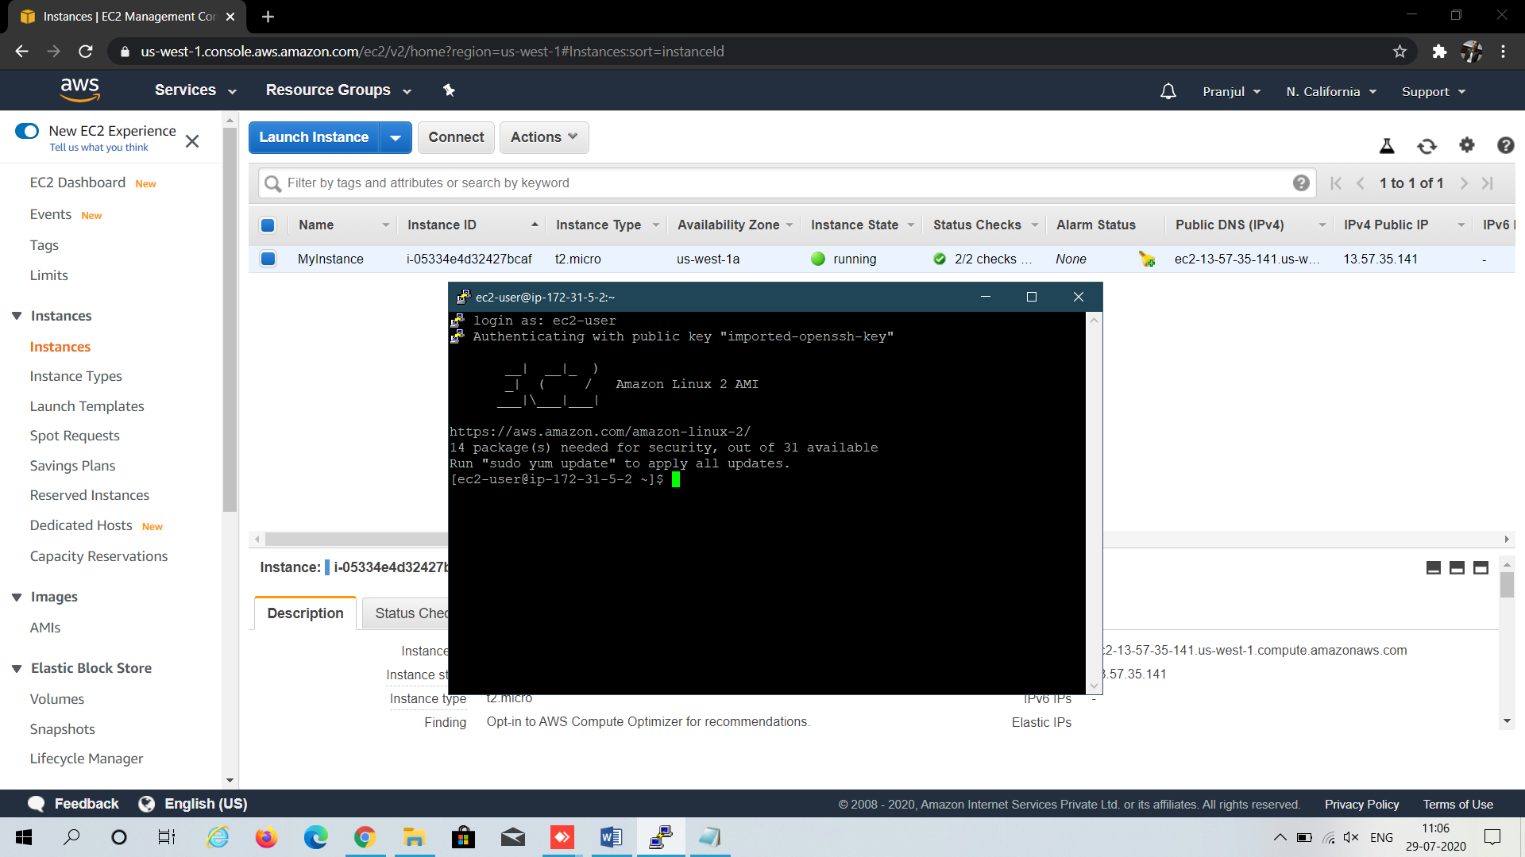

1. Now choose EBS > Volumes and create a new volume of your preferred size and type 3.

**Note**:Make sure the EBS volume and the instance are in the same zone.

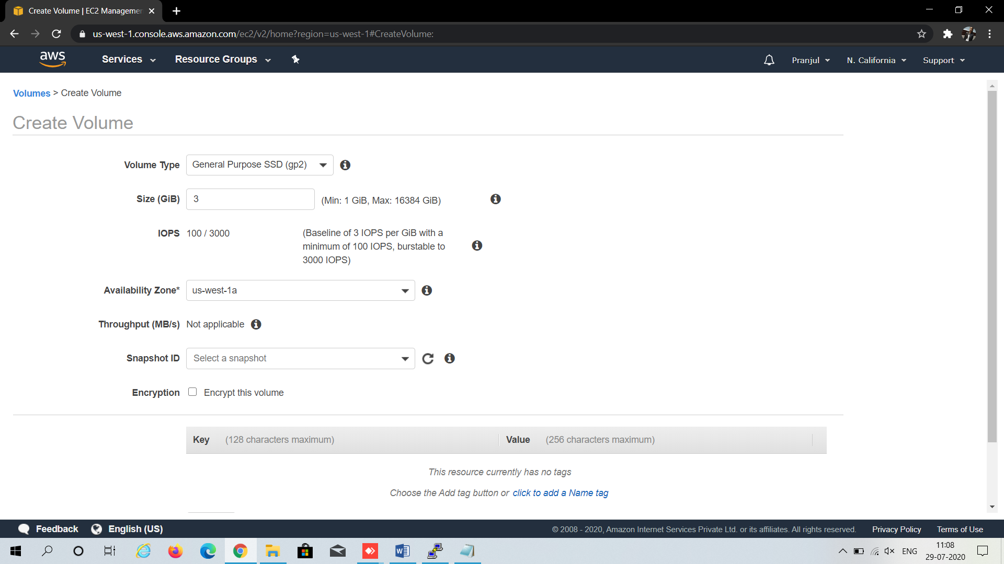

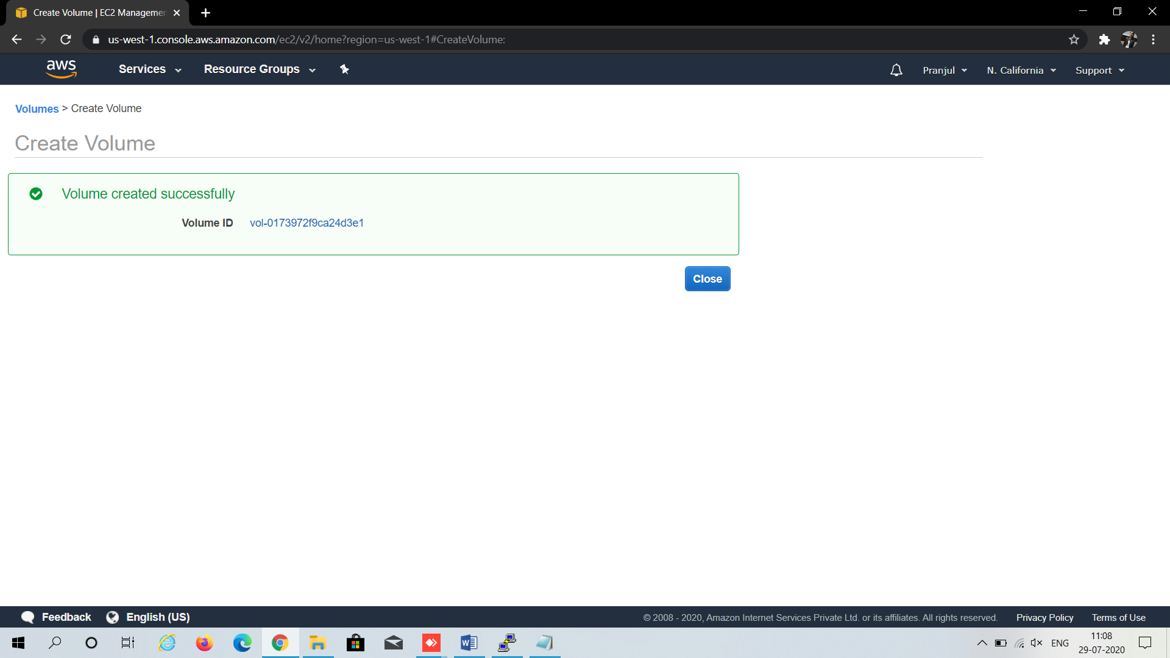

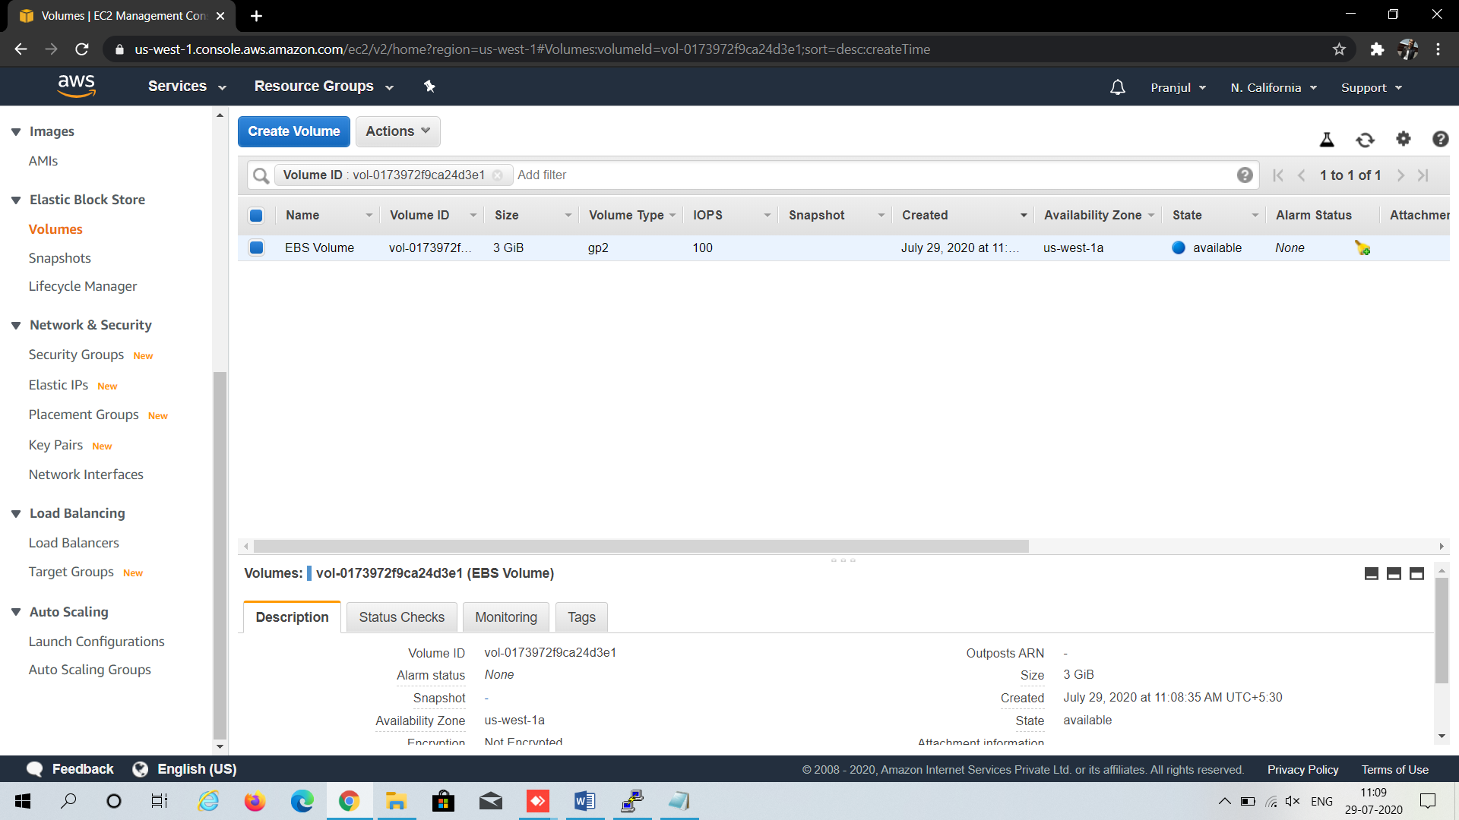

1. Select the created volume, click on actions and select the “attach volume” option.

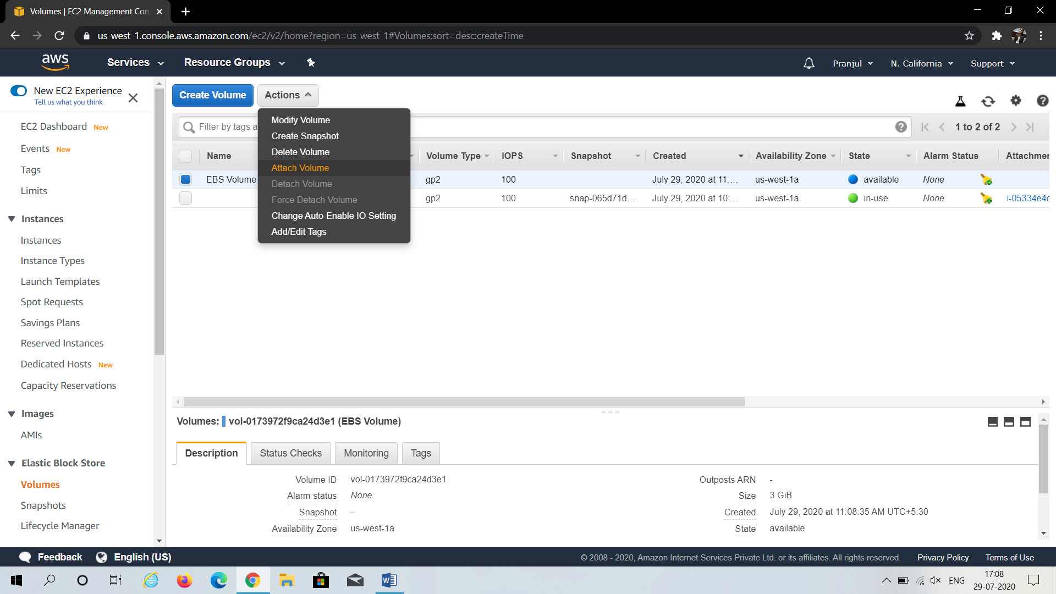

1. Select the running instance from the instance text box as shown below.

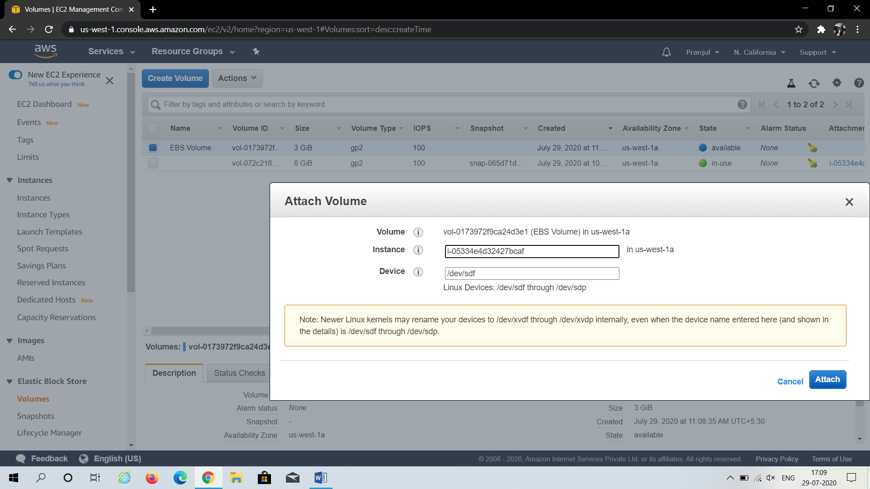

1. Now, login to your ec2 instance and list the available disks using the following command.

**lsblk**

This command will list the disk you attached to your instance.

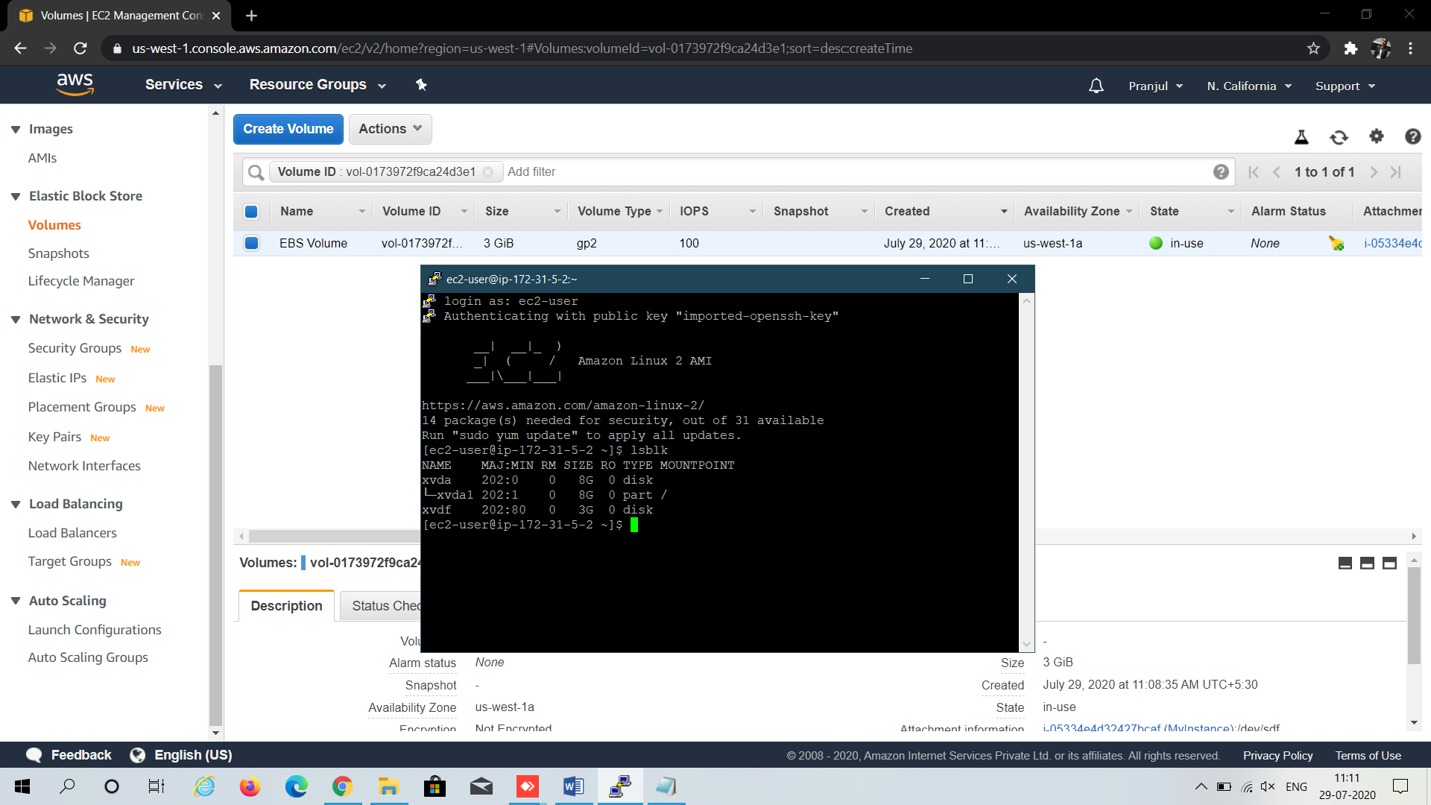

Follow these following commands-

**sudo su -**

**df –h** (shows where the disk are mounted)

**fdisk /dev/xvdf** (partitioning the volume)

**m** (shows all the tasks which can be performed)

**n** (to partition)

**p** (for primary)

it will ask the number of partition

enter **1**

enter the default partion number

enter the default partion number

**w** (to exit the table)

**lsblk** (the partition will be made)

mount the partition

**mkdir /tmp/disk2** (make a new directory)

**mount /dev/xvdf /tmp/disk2** (mount the new volume on this)

**lsblk** (mount can be seen)

**df -h** (full details can be seen)

